POWER BI

PBI Desktop

* For development work

PBI Service

* All publishing work
* Sharing of files

PBI Mobile

* To visualize the same data using mobile phones

Sources of data for Power BI

* A lot of connectors present in Power BI
* These connectors are used to connect to databases, file systems, etc.

Enrich the data

* Transform the data to clean the data
* **Power Query** is used to bring the data to the required state
* Only when the data is transformed and enriched that we can use it to create reports

Inside Power BI

* Report: to create reports in a canvas
* Data:
* Model:

.pbix is the format of the Power BI files

Dashboard

* Collection of reports

Mash-up Query Language

Parameters in Power BI

* Create parameters for dynamic location of the data source

Manage Columns

* To choose required columns
* To remove the unnecessary columns

Hands-on on Power BI Transformations

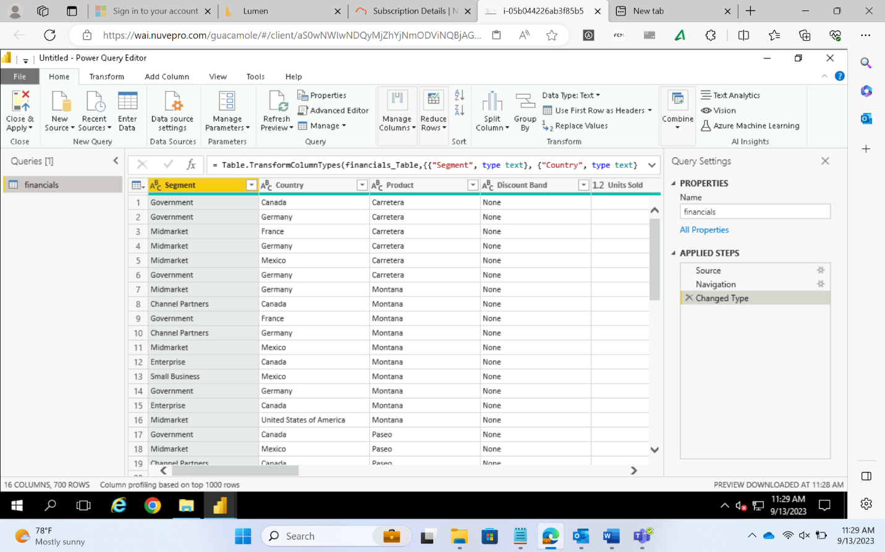

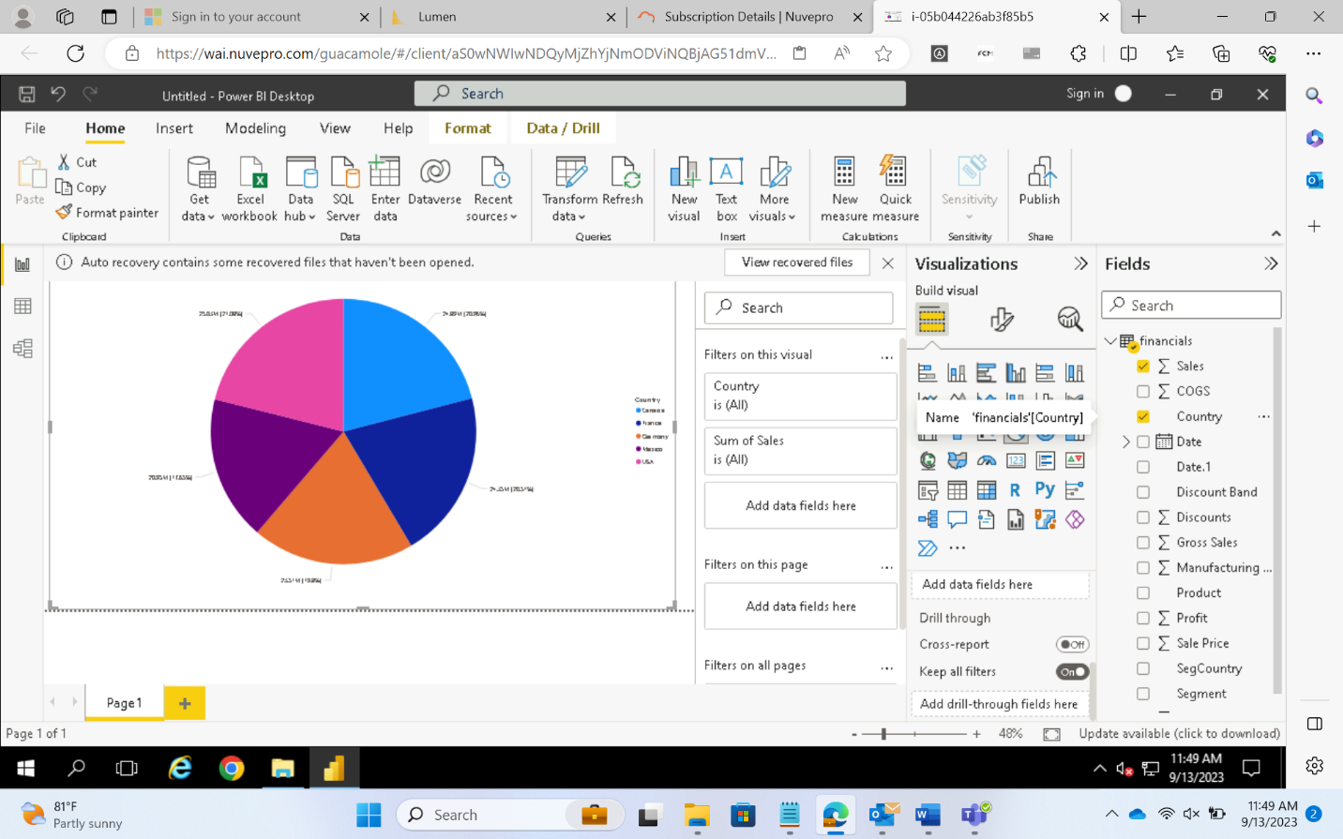

To visualize data based on date

* Use the hierarchy option

Parameter

* To dynamically give the path at run time
* This path is generally given to load files from different file sources

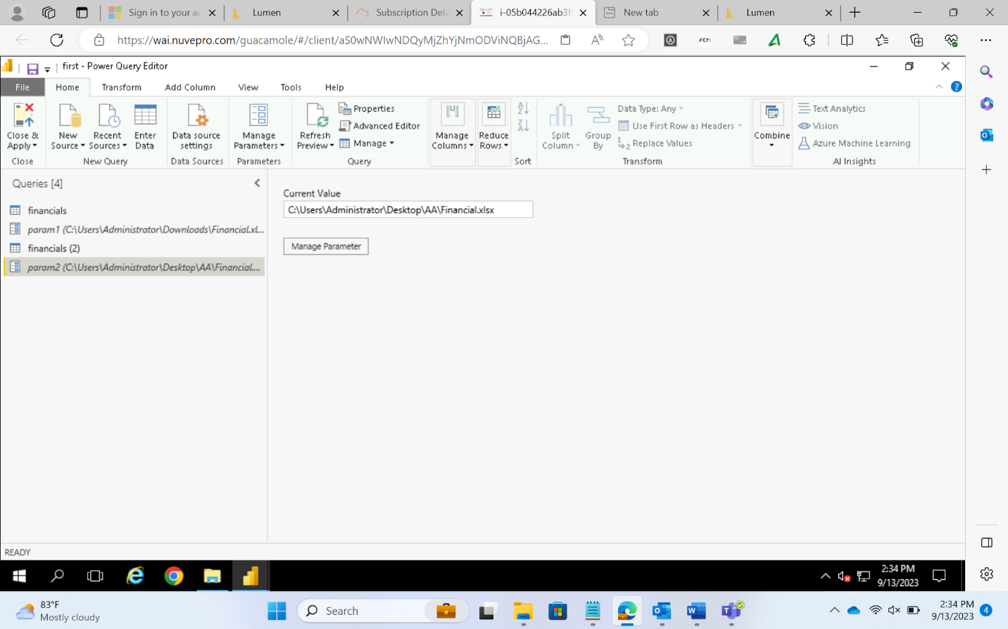

Filters in Power BI

* Visual filter
  + Filter on one visual element

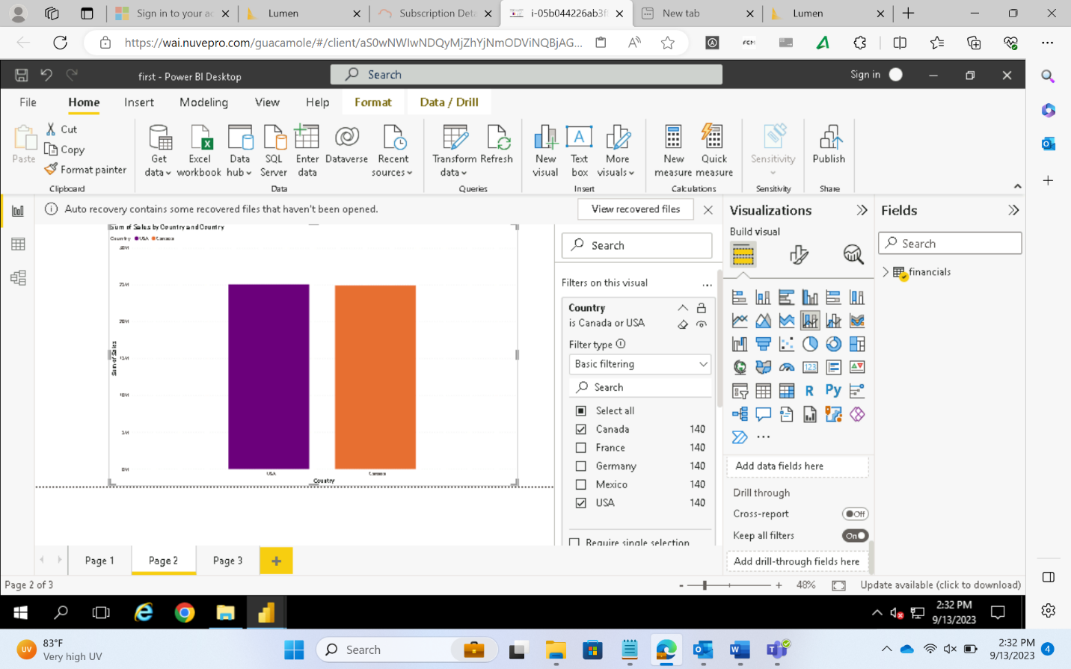

* Page filter
  + Filter on all the visual elements present in one page

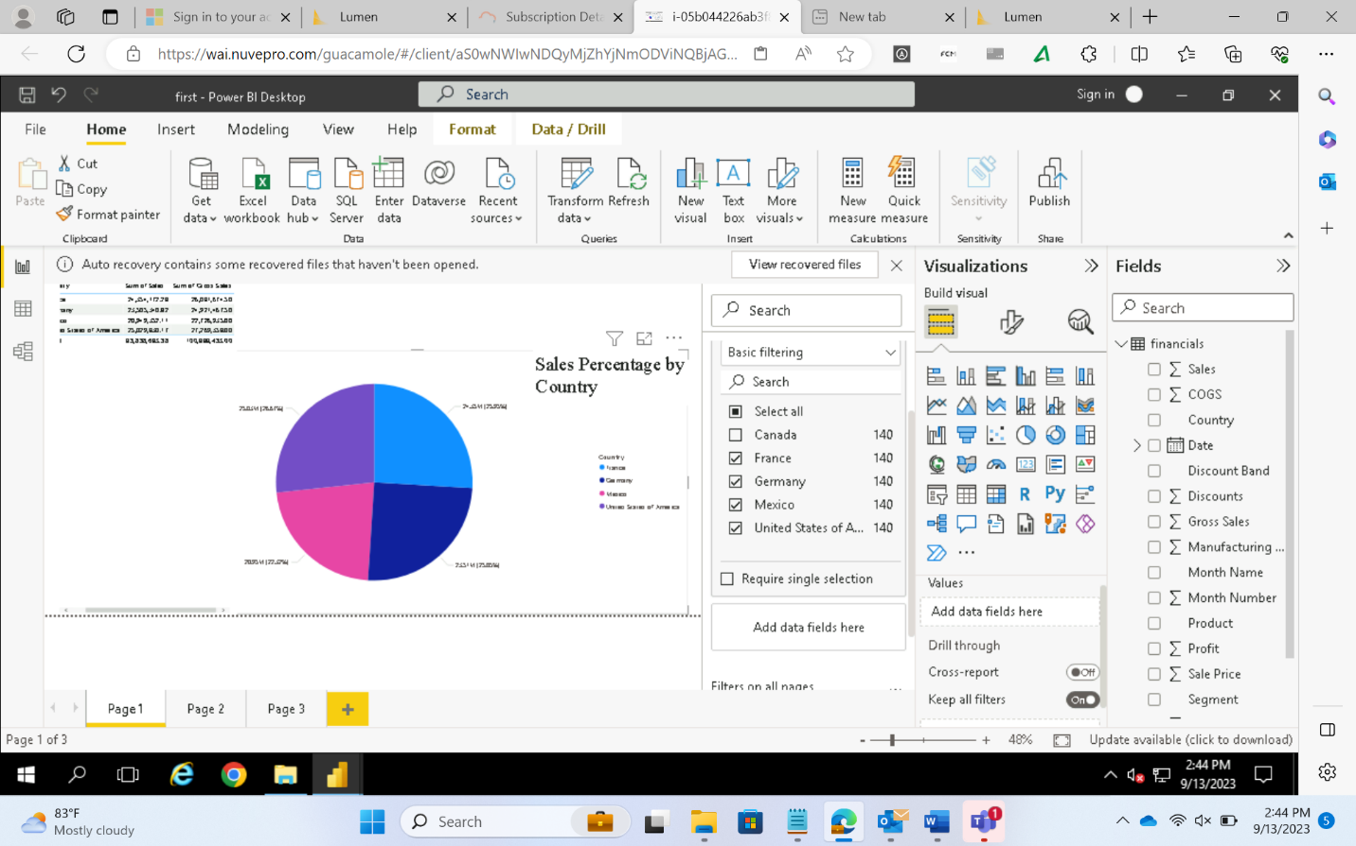

* Report filter
  + Filter on all the pages and their visual elements for a report

Slicers

* To slice the data
* It is a very interactive form of filtering

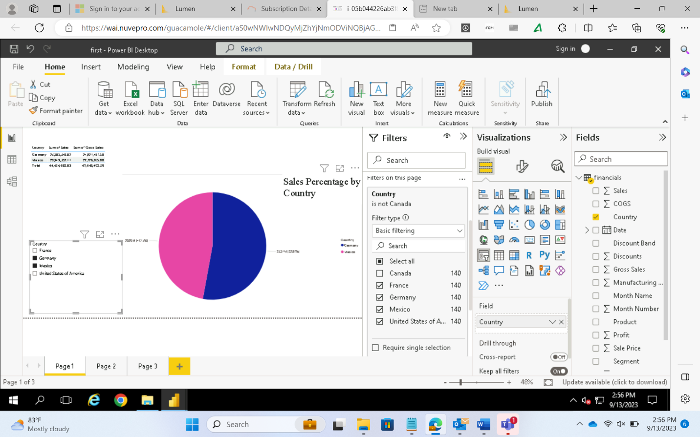

Implicit measure

* Provided by Power BI

Explicit measure

* Made by user

Languages used in Power BI

* DAX
* Mash-up Query Language

Note:

* Calculated columns when used occupy space in the table and consume memory
* Measures are similar to calculated columns. Only difference is that they do not occupy any space in the memory
* They are just a formula representation that can be used in the report directly without showing up in the table

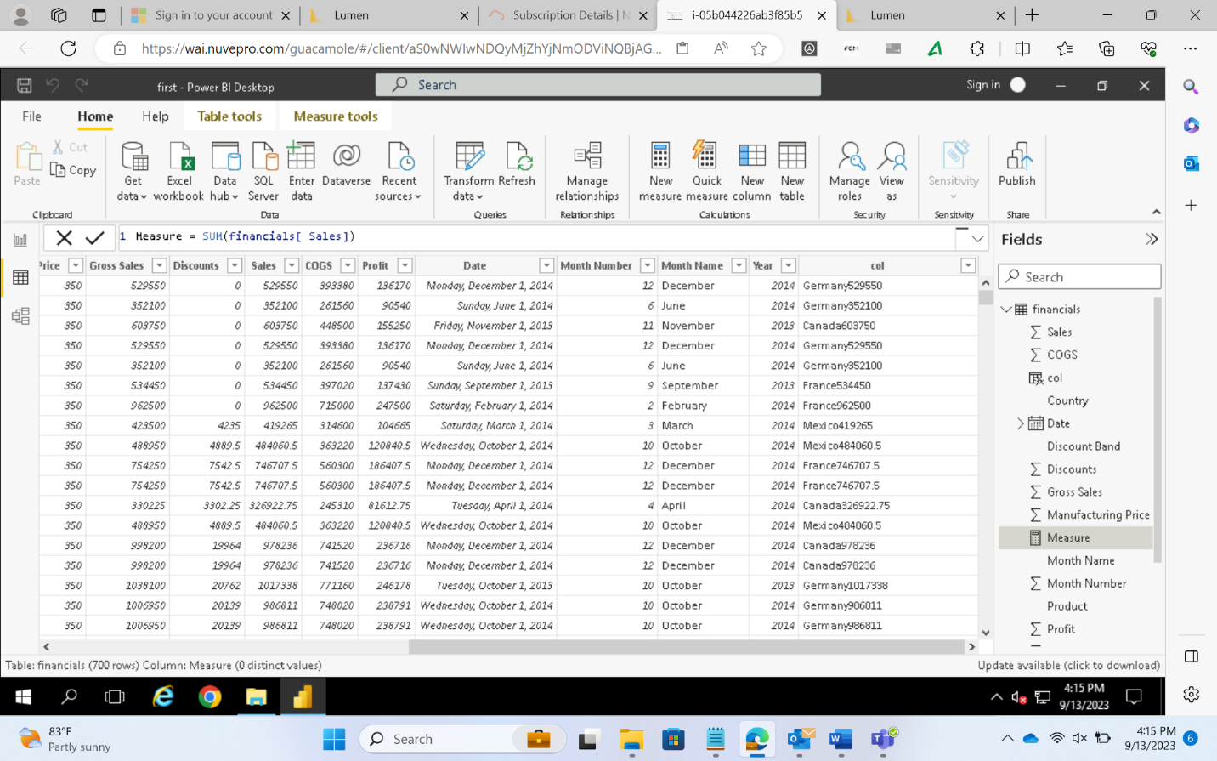

Row Level Security

* To hide some and reveal other parts of the report based on different roles

